Ref: DM/HT1/Nov24

15th November 2024

Dear Parent/carer

We are delighted your young person has joined our college family and we hope they have settled in well and enjoyed their first half-term at college.

Please find attached your young person’s grades for their first half-term in college. These progress grades are current “working at” grades and there is further clarification of the grades underneath the report If you have any questions about this report, please contact your young person’s personal tutor in the first instance.

For the rest of this academic year, there are going to be regular updates for parents/carers/guardians. This information will be uploaded to the Parent Zone of our college websites:

For students attending the Accrington & Rossendale College Campus:

<https://www.accross.ac.uk/about-us/parents-zone/>

For students attending the Nelson & Colne College Campus:

<https://www.nelson.ac.uk/about-us/parents-zone/>

Please visit the website regularly to keep up to date.

Yours faithfully Yours faithfully

cid:65b7fbf2-0cf4-414d-9891-835d89215d7e 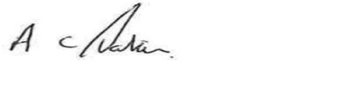

Fionnuala Swann Andrew Parkin

Campus Principal Campus Principal

Nelson & Colne College Accrington & Rossendale College